The Orchid Arcade: User Guide

# Functionality of the application

After you open the application, you will be greeted by the Games page. This page has a list of games created with the options to view the details of a game.

Most of the operations are restricted to viewing games until you register or log in. You can click on the Register/Log in buttons on the top of the screen.

After you Register or Log in with a user, you will be sent a verification code to your email:

After you verify the code, this takes you to the Details page of your user. Here, you can also edit your profile details:

If the user is a developer, they can create, edit or delete their games:

When a user is logged in, when checking the list of games they have the option to buy them and add them to their list:

The user can also add, edit or delete reviews for any specific game they have.

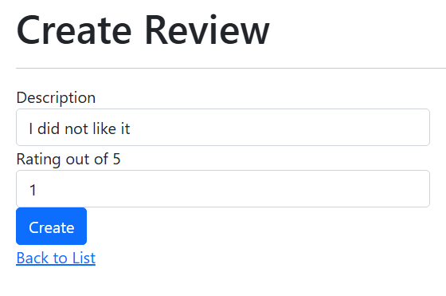

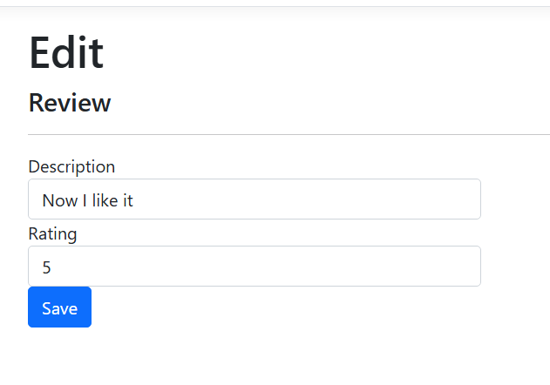

Finally, users can log out of the application and their sessions will be terminated:

